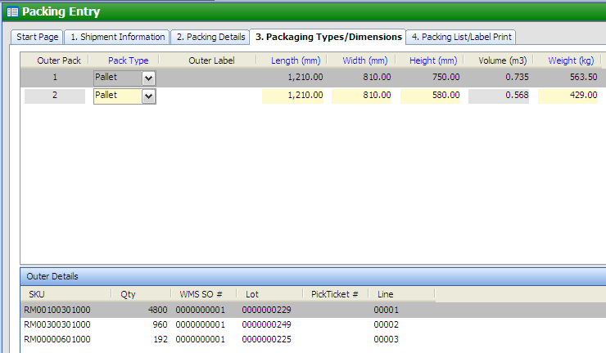

Pack Type:
1. Carton
2. ½ pallet 80x60x65
3. Full pallet 120x80x95
4. Heavy Carboard Crate 120x80x95 @ USD41.85 (Chargeable)
5. Heavy cardboard crate 80x60x65 @ 18.10 (Chargeable)

Once whse choose the chargeable pallet size (4 & 5), system will automatically calculate the total packing cost in Order Maintenance.
